**Constraint satisfaction problems**

This project is an application to solve constraint satisfaction problems, this application gives you the choice to choose the problem that you want to solve which are NQueens and Map coloring and then also gives you the freedom to choose the solving algorithm, and it contains backtracking and forward checking.

Now before jumping into the application you should install a module called “pygame”

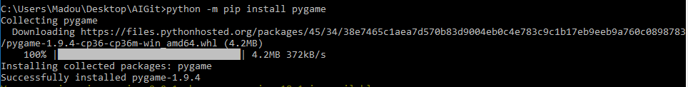

Now you can start the project by running main.py. We have 4 possible cases:

1- NQueens with backtrack search

Here’s the output of the console

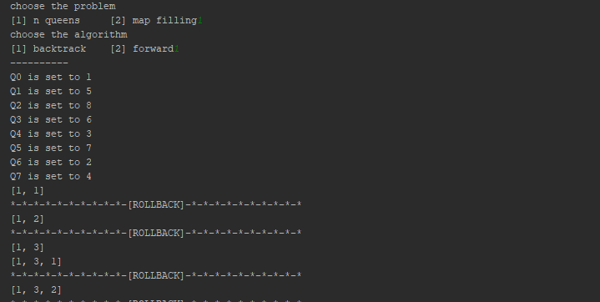

And at the same time we can see a graphical interface showing the progress

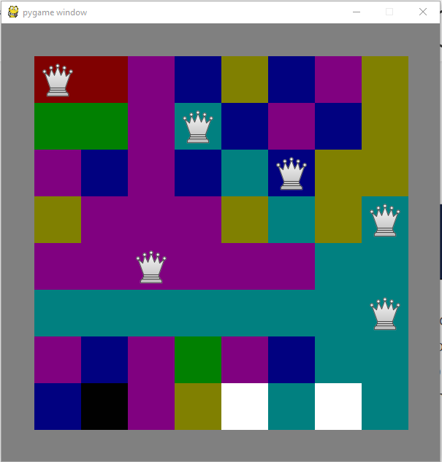

2- NQueens with forward checking

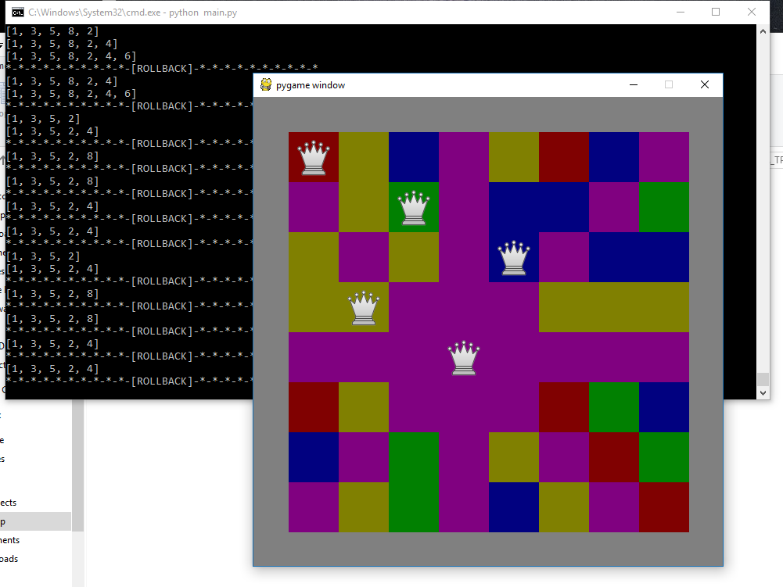

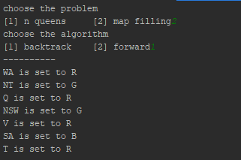3- Map filling with backtrack search

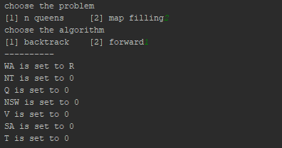

We can the progress in the first screen shot and the result in the second.

4- Map filling with forward checking

